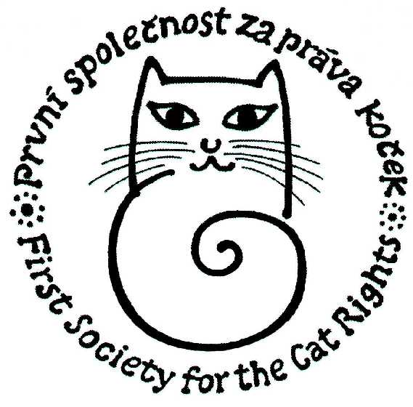

First society for the cat rights
Tel, Fax: +420 257 923 106, mobil: +420 737 601 008
e-mail: prava.kocek@atlas.cz
web: www.kockaapravo.cz

is arranging

gathering for the help of abandoned animals in Lebanon

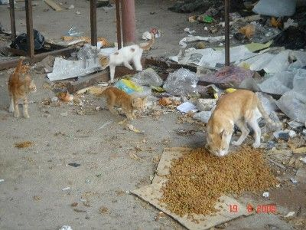
In connection with the call appeal for the help of abandoned, hungry and terrified animals in Lebanon in the area hit by war that we received from PETA and BETA organization we are addressing to all sympathetic people with a request for financial gift for these powerless animals. Animals were abandoned by their owners who were forced to run away from their homes and were not allowed to take them with them. Now BETA organization
(http://animals.beirut.com) and PETA organization
(http://www.peta.org) cares about these animals and and all the money will be sent to their bank accounts.

Gathering is on from October 4th 2006 to March 3rd 2007.
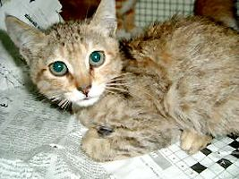

Please send your
cotributions to the
bank account number
756 098 028/2400
(eBanka, a.s. Prague 1)

http://www.ebanka.cz/tran_uct/756098028.html

Thank you for your support !

