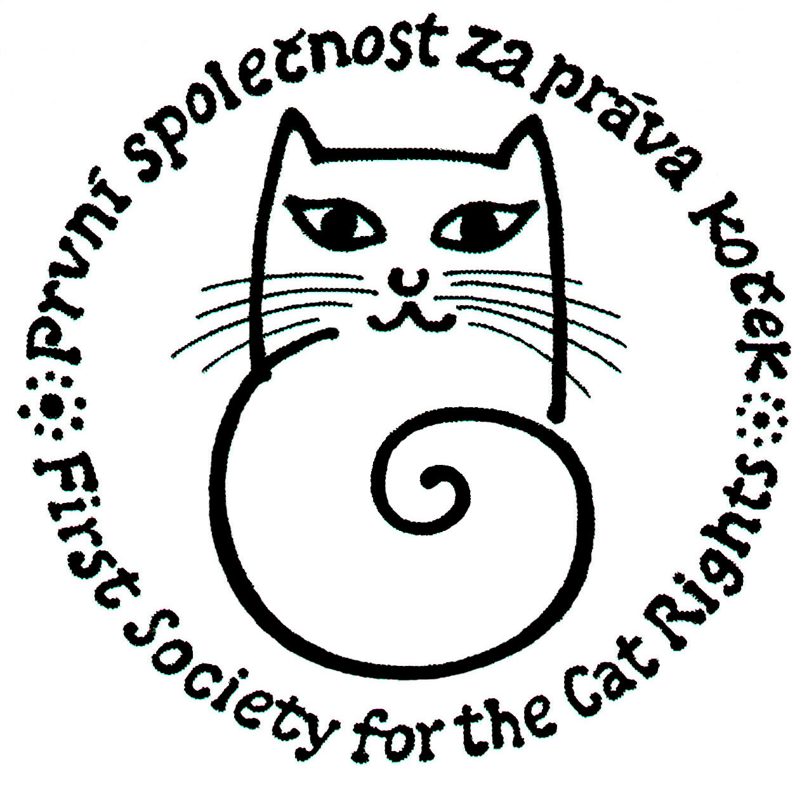
First Society for the Cat Rights, civic society
Na Bluku 431, 25228 Černošice
Telephone, answering machine, fax:+420 257 923, mobile:+420 737 601 008
e-mail:info@kockaapravo.cz
www: http://www.kockaapravo.cz/

Press Release of the First Society for the Cat Rights, o.s. (civic society) 26 July 2010

The Internatial Day of Homeless Animals and Candlelight Vigils
Let us inform you about the International Day of Homeless Animals initiated by the International Society for Cat Rights. This day is listed in the Survey of internationally significant days and has been celebrated always on the 3rd Saturday in August since 1992.
We have been trying to introduce celebration of the Day for the fifth year in our country. Here is a briefing for those who have not read the previous press releases.
The International Day of Homeless Animals including the Candlelight Vigils is held to commemorate innocent victims of human irresponsibility i.e. the animals who lost their lives inasmuch there were not enough homes for them due to excessive reproduction, and also to honour selfless people who have dedicated their lives to prevent uncontrolled reproduction and suffering of unwanted cats and dogs.
In our opinion it is important to initiate the International Day of Homeless Animals in the Czech Republic because it will draw attention: to the suffering of abandoned cats and dogs; to the irresponsibility of owners and breeders of animals; and to the urging need of legislative changes to introduce responsibility of municipalities for implementation of abandoned animals neutering program. We would like to enforce the following changes: of Section 24 para 1 of the Animal Protection Law; of Section 46 subparagraph c) of the veterinary law; and of Section 13b para 1 subparagraph d) of the Animal Protection Law so that the municipality itself or in co-operation with another municipality or person should be obliged to establish and operate shelters for stray and abandoned animals and regulate population of abandoned aminals by way of supporting neutering, i.e. instead of the existing wording „the municipality may“ and „regulation of population by limiting uncontrolled sources of fodder.“ In view of efficiency, the ban on feeding can be viewed as a contraproductive solution of regulation of abandoned animals population without analogy in the advanced world. It is because the abandoned animals will multiply regardless of their well-being. On the contrary, at times when their population is endangered, they increase in numbers to cover any losses. Hence restriction on food only results in a number of weakened individuals thus facilitating propagation of various diseases among them.
Inasmuch this is an extraordinarily important englightment event, we call upon all cats and dogs protection associations including existing shelters, asylum homes and home deposits to hold their own events in order to commemorate deceased animals, to push through the erection of sufficient number of asylums for abandoned cats and dogs and in particular to implement a functional neutering program.
This year, local celebrations and candlelight vigils will be held traditionally for the fifth time in Příbor and for the first time in Černošice on 21 August from 6:00 p.m. We enclose an invitation card. We are looking forward for your participation and support. The photo documentation will appear on our websites on 22 August.
We call upon all compassionate people, supporters and friends of animals to join celebrations of the Day, both the worldwide vigils on ISAR sites and by lighting a candle on our Virtual Vigils sites or by their own event or home ceremony with lighting candles for their hairy pals. Please remember the deceased animals on Saturday 21 August at 6:00 p.m. Write the name of your deceased friend on a piece of paper or remember cats you have seen in the street and whom you could not offer home; or your attention was drawn by an old dog who died in a shelter because no home could be found for him. Put in front of you a photo, a picture with the name of the animal, light a candle, say a poem, a prayer of forgiveness, have a chat with them for a while …
Thank you to commemorate the animals.

Contact: Alice Oppová, tel.fax: 257 923 106, mobile: 731 601 008, e-mail: info@kockaapravo.cz, www.kockaapravo.cz, Eva Kopáčová, member of the Society and chairwoman of Civic Society Help Animals by Art („Uměním na pomoc zvířatům“), mobil: 739 027 867, e-mail: info@kockyaumeni.cz, http://kockyaumeni.cz/, Václav Vlček, deposit in Příbor, mobile: 737 919 861, e-mail: vaclav.vlcekst@seznam.cz

